50 Weather Words



thermometer atmosphere Fahrenheit barometer hurricane fog lightning storm sunny cold hail heat mist snow warm
temperate altitude blizzard forecast freezing humidity wind
Celsius climate cyclone degrees drizzle drought monsoon
precipitation condensation evaporation meteorology temperature
rainbow seasons thunder tornado typhoon autumn isobar
spring summer winter cloud flood frost ozone sleet ice

50 Weather Words

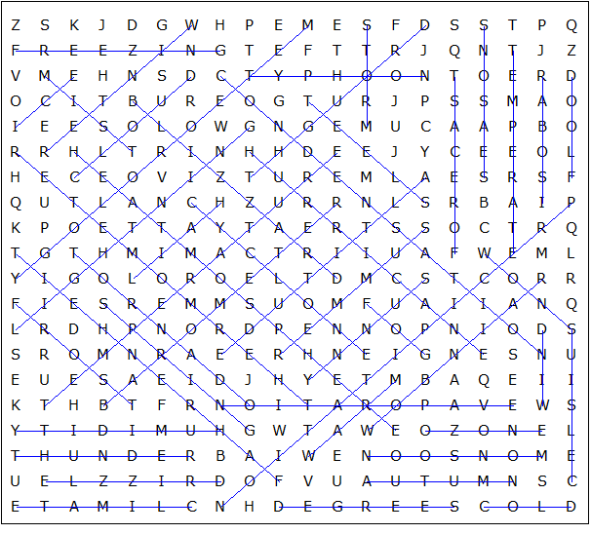

This puzzle was created in seconds using Toolbox, available for only £10 from discoveryeducationalsoftware.co.uk

